1. API-Backend

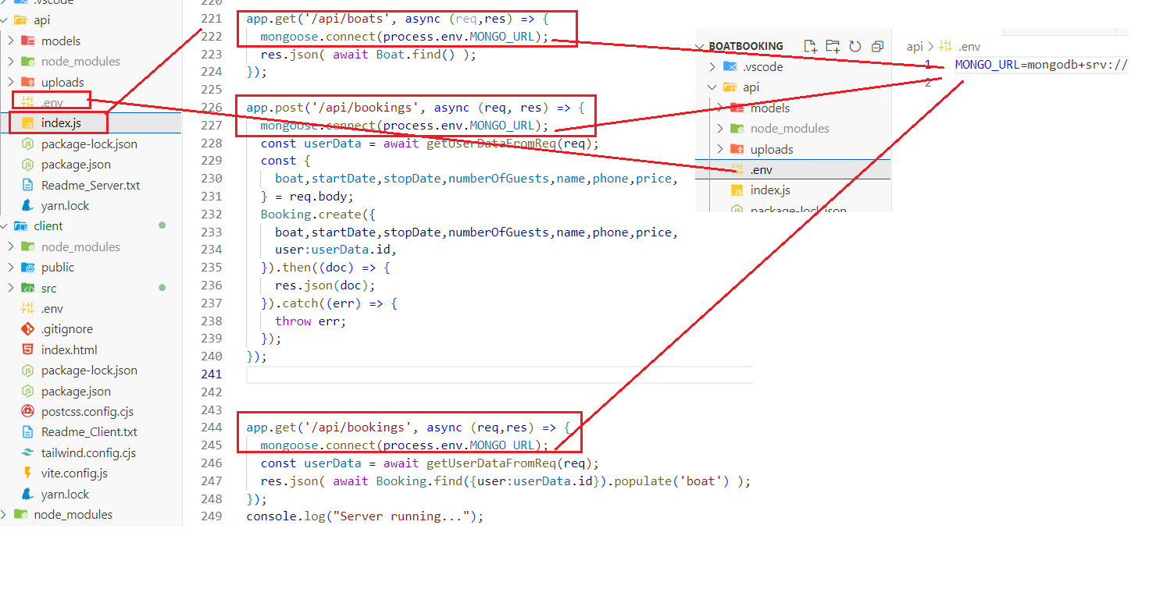

The server Api stores Mongo DB URL in the .env file, this URL is used to connect to Mongo DB and post or get the data. In this screen we have the crud function to get the boats and the bookings, and the post function to store the bookings data

1. Booking boat link in indexPage

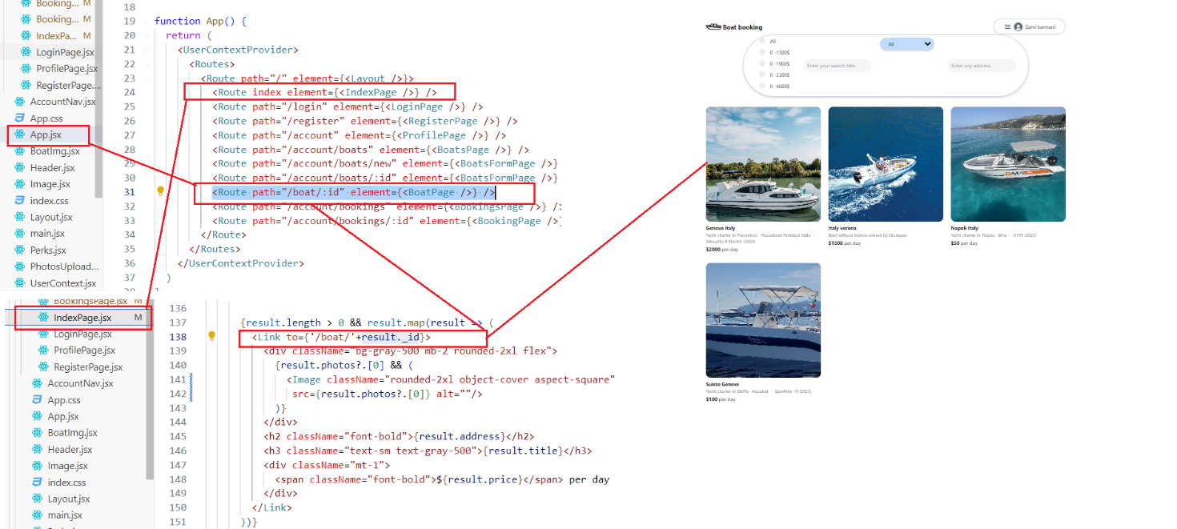

In the WebApp frontpage displaying all the boats, clicking on one boat redirect the user into that specific boat page containing its information.

1. Boat Page

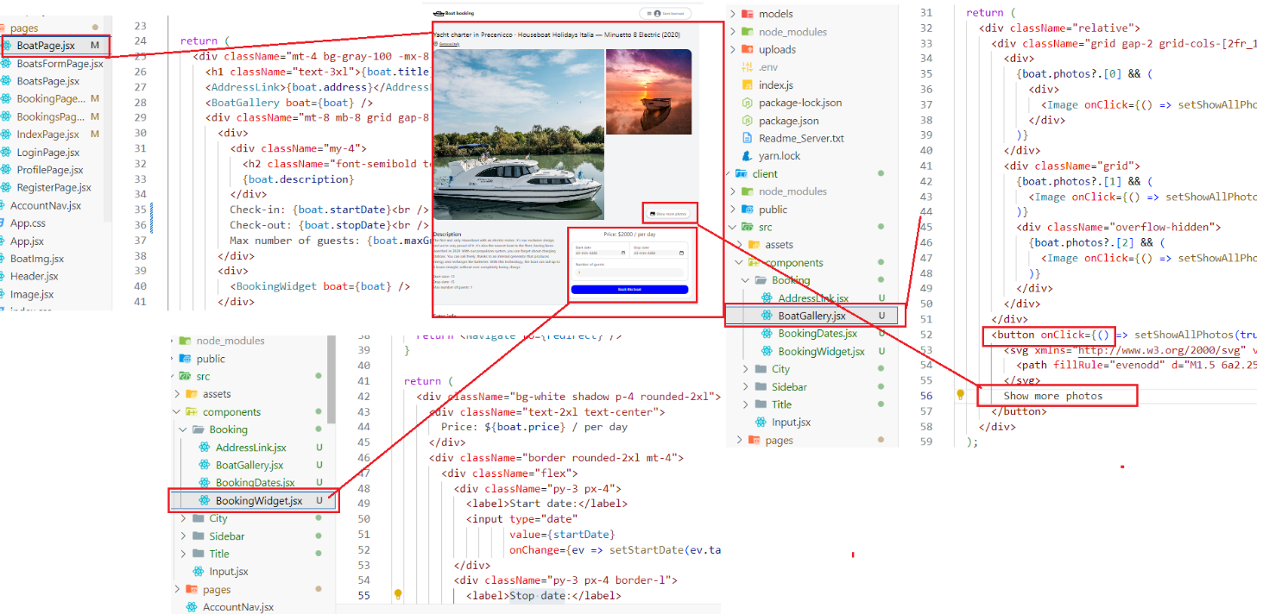

The user can see more photos of the boat by clicking Show more photos on the corner. He can also pick the starting and ending dates. Afterwords the price is calculated and displayed. Finally the user can validate the booking by clicking the “book this boat” button.

1. On Clicking ”Book this boat” Button

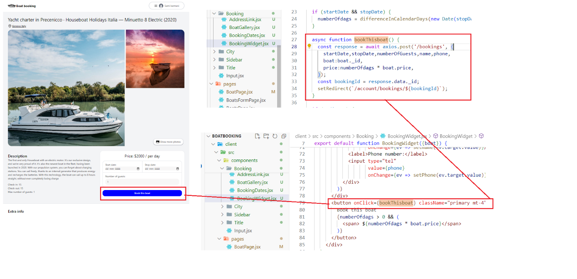

Upon clicking the button, the asynchronous function bookthisboat() is triggered and the booking information is sent to the API using axios which is a framework for sending and retrieving data to/from the server.

FrontEnd-API-MongoDB

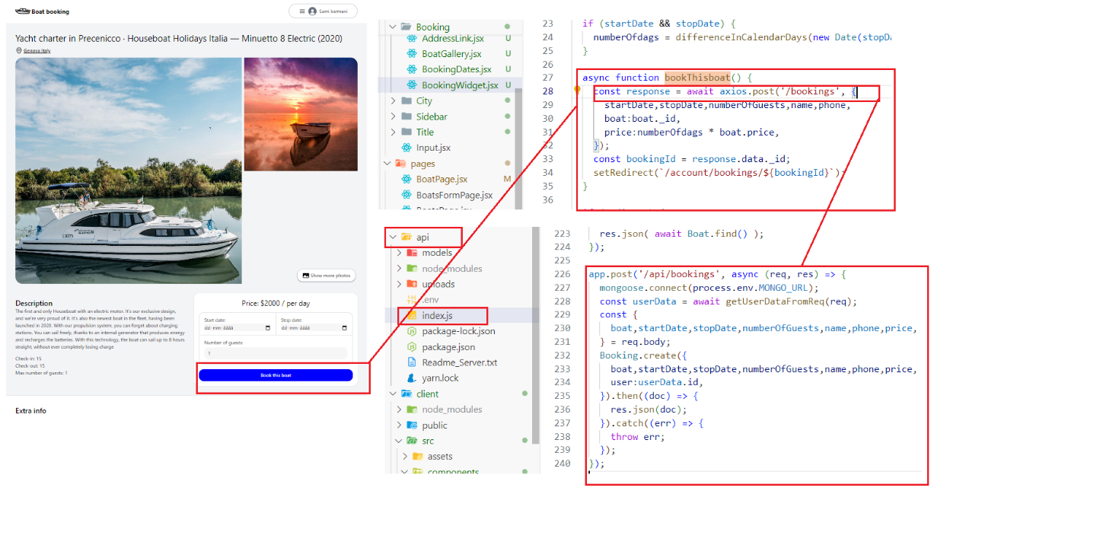

bookThisboat() calls the API post to store booking data in MongoDB.

Using mongoose the API is already connected to MongoDB on the cloud and the new booking is added to bookings table.

Finally the user is redirected to bookings page in which the booked boat is displayed.

Retrieving Data from Server

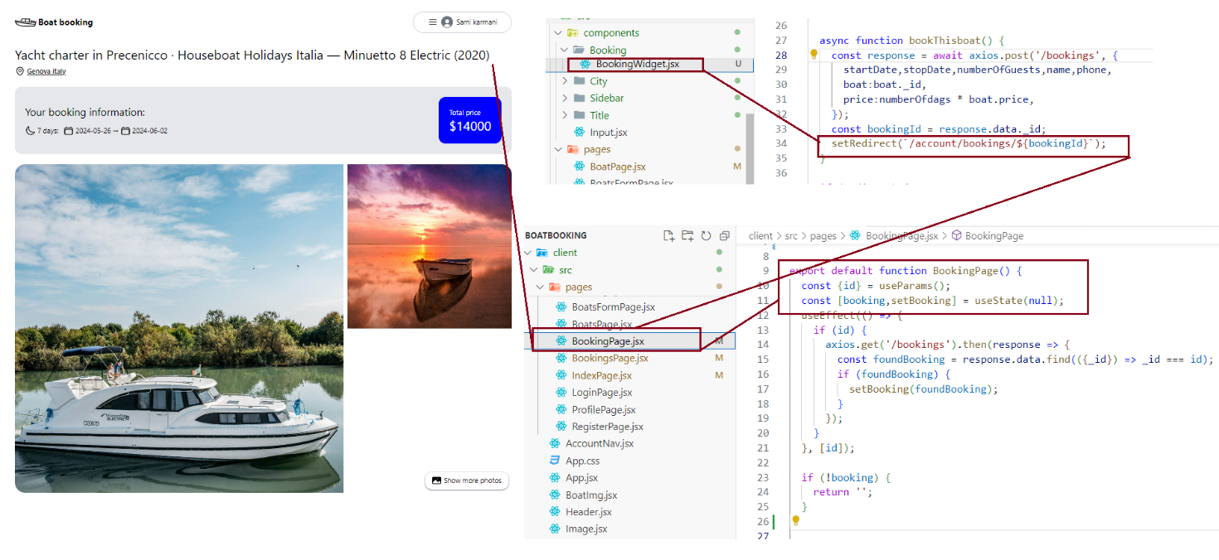

Upon opening the booking information page, the stored data on the MongoDB server is retrieved and displayed on the page using axios framework. Basically the boatId is found on the MongoDB bookings table and then retrieved through the API then displayed finally on booking page.